Registration Information  Current Preschool Students  - Begin Registration on January 8th  St. Timothy Parishioners:  - Saturday February 3rd from 9 AM- Noon  Local Community:  - Saturday February 3rd from Noon – 4PM  A non-refundable $100 registration fee is due upon registration. A one-time supply fee is due in August at orientation.  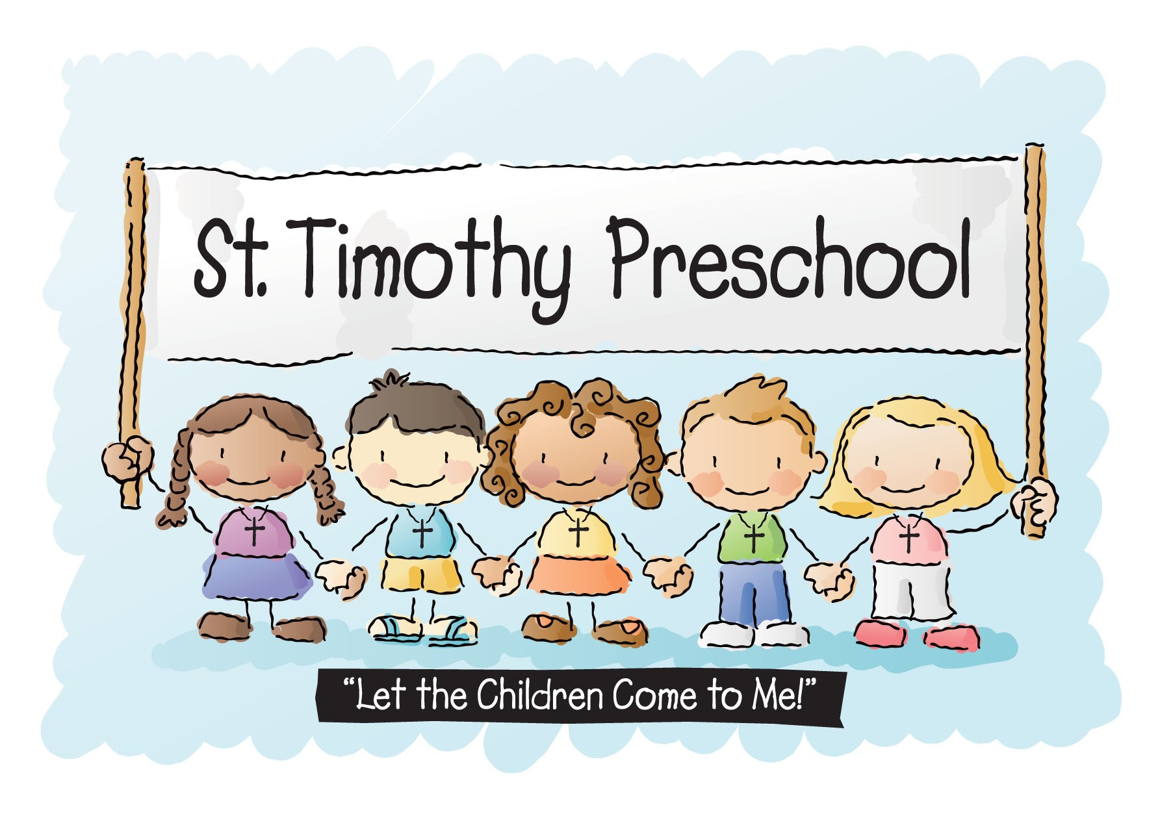  Contact: SARA SCHLEGEL, Director  PO Box 120, Union, KY 41091  859-384-1100 Ext. 109  sschlegel@saint-timothy.org |  |  | St. Timothy Preschool 2018-2019  Contact: SARA SCHLEGEL, Director  - St. Timothy Preschool  PO Box 120, Union, KY 41091  859-384-1100 Ext. 1109  sschlegel@saint-timothy.org

Goals of St. Timothy Preschool  St. Timothy Preschool will provide a nurturing atmosphere where children can grow academically, spiritually, physically, and emotionally by:  - Teaching children through a Catholic foundation of bible stories, scripture, and prayer that God loves them and listens to them.  - Instilling in children that we are all called to serve one another through Service Learning.  - Providing an atmosphere where hands on learning and experiential learning are foundations.  - Introducing children to a variety of literature, music, art, science, technology, and academic activities.  - Providing children opportunities to further develop fine gross and motor skills through play and planned activities.  - Teaching appropriate peer interactions and self-control through sharing, good manners, and cooperation.  - Instilling in the children a sense of self-worth and self-confidence.  - Preparing children for a successful transition to Kindergarten.  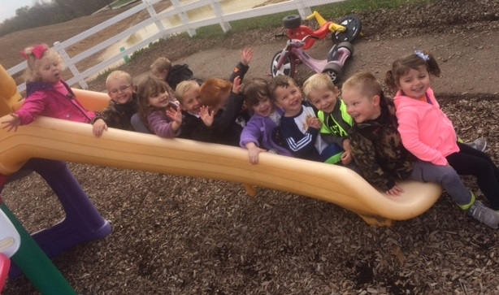 |  |  | Program Choices  3-Year-Old Program ~ $185 per month  Meets 2 days a week (3 Choices) ~ Age 3 by 8/1/18  - Tues/Thurs Morning  - Tues/Thurs Afternoon  - Wed/Fri Morning  Hours: Morning 8:30 – 11:30  Afternoon 12:15 – 3:15  4-Year-Old Program ~ $210 per month  Meets 3 days a week (3 Choices) ~ Age 4 by 8/1/18  - Mon/Wed/Fri Morning  - Mon/Tues/Thurs Afternoon  - Mon/Tues/Thurs Morning  Hours: Morning 8:30 – 11:30  Afternoon 12:15 – 3:15  Kindergarten Readiness Program ~ $260 per month  - Monday through Friday from 8:30 – 11:30AM  - Child must be the age of 4 by 6/1/18  - Class is intended for those who need one more year of preschool to transition to Kindergarten or do not make the August 1st birth date cut off for Kindergarten enrollment.

