In-Parish Tuition Rates
# Of Children |  |  |  | Tuition |  | Fees |  | Total Tuition |  | Deposit |  | 1% Discount Full Pmt. By July 1st
1 Child |  |  |  | $5,145 |  | $450 |  | $5,595 |  | -$200 |  | $5,539.05
2 Children |  |  | $8,232 |  | $720 |  | $8,952 |  | -$400 |  | $8,862.48
3 Children |  |  |  | $9,261 |  | $1,080 |  | $10,341 |  | -$600 |  | $10,237.59
4+ Children |  |  |  | $9,261 |  | $1,440 |  | $10,701 |  | -$800 |  | $10,593.99
Out-Of-Parish Tuition Rates
# Of Children |  |  |  | Tuition |  | Fees |  | Total Tuition |  | Deposit |  | 1% Discount Full Pmt. By July 1st
1 Child |  |  |  | $6,174 |  | $450 |  | $6,624 |  | -$200 |  | $6,557.76
2 Children |  |  |  | $9,878 |  | $720 |  | $10,598 |  | -$400 |  | $10,492.02
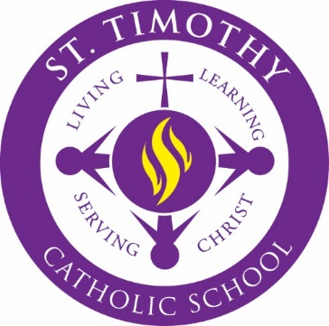

St. Timothy Catholic School will be using SMART Tuition for the 2017-2018 school year. Please go to the website found on the SMART Tuition flyer included in your acceptance package. Use code 12974 to enroll your student(s). Please contact Jennifer Casson via email at jcasson@saint-timothy.org if you have questions.

